Lab Exercise 7– Creating Pods in Kubernetes
Below is a lab exercise that will help you understand and practice creating pods in Kubernetes:
Task 1: Start Kubernetes in Docker-Desktop
- Start Kubernetes service in Docker-Desktop
Task 2: Creating a Simple Pod
- Create a simple YAML manifest file named pod.yaml to define a basic Pod in Kubernetes. An example of the file content is as follows:
apiVersion: v1
kind: Pod
metadata:
name: my-nginx-pod
labels:
app: lbnginx
spec:
containers:
- name: nginx-container
image: nginx
Apply the Pod configuration using the following command:
kubectl apply -f pod.yaml
Check the status of the Pod using the following command:
kubectl get pods

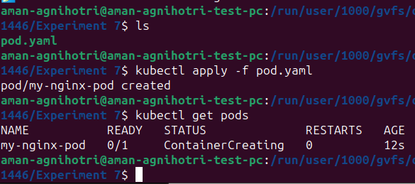
Output -
Task 3: Accessing the Pod
Access the Pod by using port forwarding to the container. Run the following command:
kubectl port-forward my-nginx-pod 8080:80
Output -
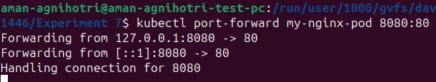
Access the Nginx server running in the Pod by opening a web browser and navigating to http://localhost:8080.
Output -
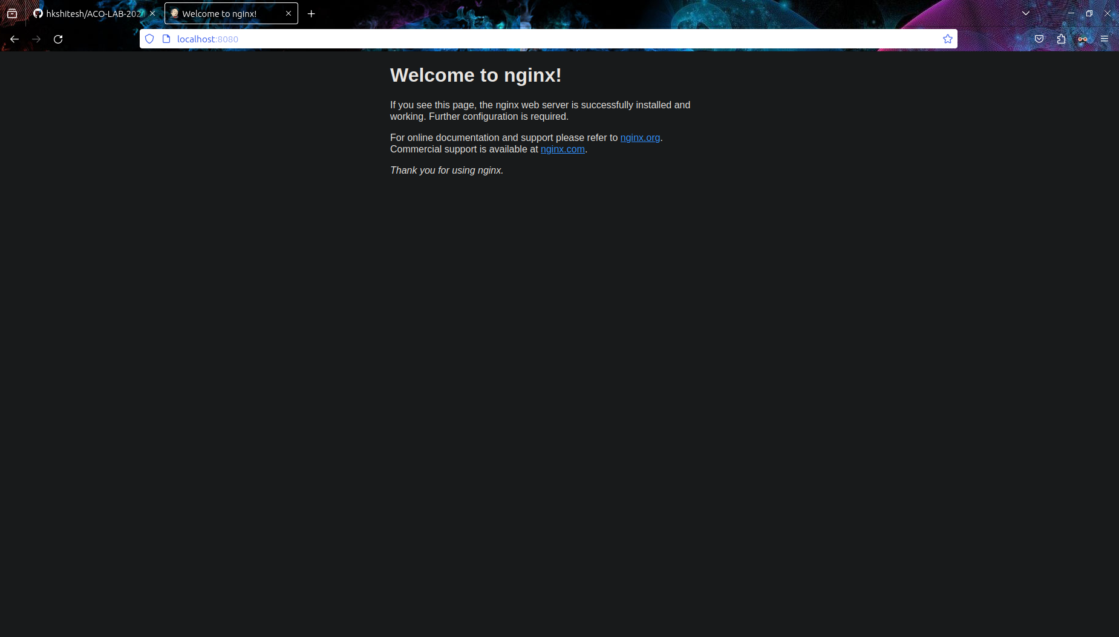
Task 4: Exploring Pod Details
Retrieve detailed information about the Pod using the following command:
kubectl describe pod my-nginx-pod
Output -
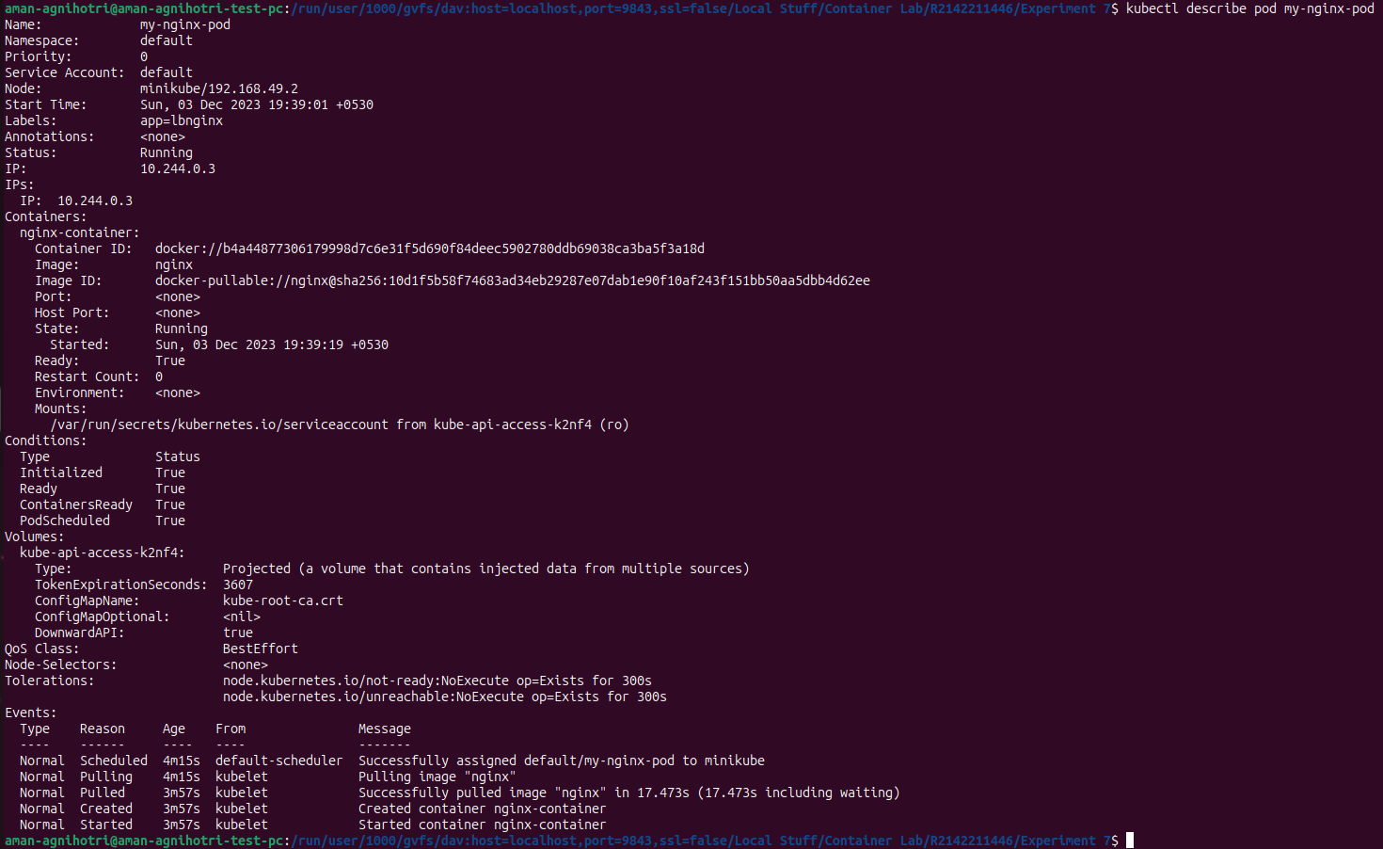
Check the logs of the Pod to understand its behavior using the following command:
kubectl logs my-nginx-pod
Output -
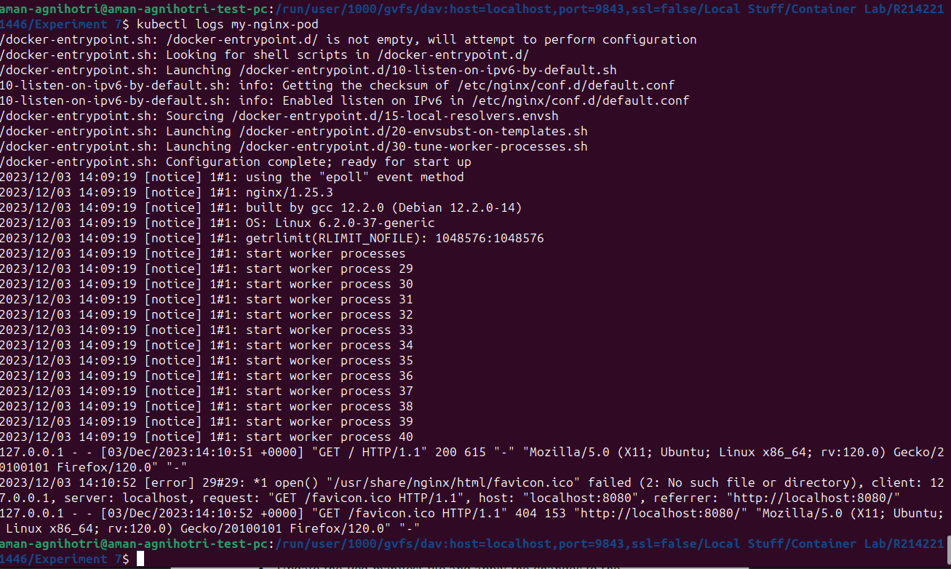

Task 5: Deleting the Pod
Delete the Pod using the following command:
kubectl delete pod my-nginx-pod
Verify that the Pod has been deleted by running the kubectl get pods command.
Output -
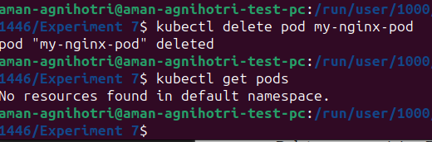

Task 6: Advanced Pod Configuration
- Experiment with advanced Pod configuration options such as environment variables, volume mounts, resource limits, and labels.
- Update the Pod manifest file and apply the changes to the Kubernetes cluster.

Task 7: Cleanup
Delete any remaining Pods, services, and deployments created during the exercise using the appropriate kubectl delete commands.
Task 8: Documentation and Best Practices
Document your findings and the best practices for creating and managing Pods in Kubernetes.
Through this exercise, you'll gain a better understanding of how to create, manage, and interact with Pods in Kubernetes. Adjust the exercise based on your specific use case and requirements.

